**Masking ROIs**

Table of Contents

Needs: 1

Procedure – Copying the folder and prepping the Excel file: 1

Procedure – Using Matlab to rename the files: 2

Procedure – Using Matlab to rename the files to their original name: 2

# Needs:

1. Microsoft Excel
2. Matlab and access to these 3 scripts:
   1. File_Masking_1_Generate_List.m
   2. File_Masking_2_Rename_Files.m
   3. File_Masking_3_Rename_Files_Back.m

# Procedure – Copying the folder and prepping the Excel file:

1. Navigate to the folder that has your files to be masked. **It is wise to create a safe backup of those files in another location.**
2. Within the folder that has the files to be masked, paste the template file “RenameCode.xlsm.” As of this writing, the .xlsm file needs to be in the same folder as the files to mask. 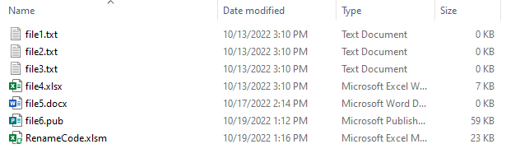
3. Run the Matlab code “File_Masking_1_Generate_List.m”
   1. The Matlab script will prompt you to choose a folder that contains the files to mask + the .xlsm file. Select the folder.
4. You are now done with “File_Masking_1_Generate_List.m”
5. Open the “RenameCode.xlsm” file. It should have been updated with a list of the entire folder contents under column A.
   1. It may prompt you to “enable macros” at the top of the Excel window. Click to enable.
   2. Click the blue button “Step 2: Generate Mask Names”, which will insert a randomized number along with a duplicate verification in columns B and C.
6. Regardless of the number of files in your list, you should see an equal number of rows in columns B and C. It will look like this:

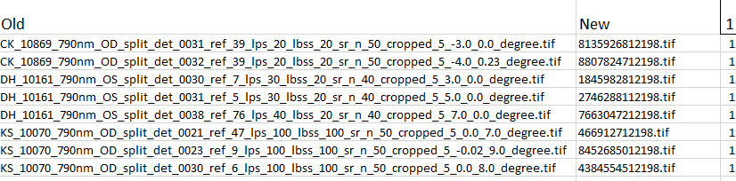

* 1. Column A has “Old” along with all the file names.
  2. Column B has “New” along with the new names it will assign to each file.
  3. Column C should have 1 at the top, along with a 1 in every additional row.
     1. If cell C1 ever shows a number higher than 1, reclick the “Step 2: Generate Mask Names” button and keep clicking again until cell C1 shows number 1.
  4. Click the button “Step 3: Generate Coordinate File Names” which will populate the appropriate rename files and formats on the “Unmasking” tab. Only a single click of the button is needed.

1. The final action for this section is to save the Excel file and close it.

# Procedure – Using Matlab to rename the files:

1. Run the Matlab code “File_Masking_2_Rename_Files.m”
   1. The Matlab script will prompt you to choose a folder that contains the files to mask + the .xlsm file. Select the folder. The file “RenameCode.xlsm” will stay the same, while all the other files will be assigned a unique, random number value.
2. You are now done with “File_Masking_2_Rename_Files.m”

# Procedure – Using Matlab to rename the files to their original name:

1. **If necessary, create a safe backup of the files in another location before you rename back to their original names.**
2. Run the Matlab code “File_Masking_3_Rename_Files_Back.m”
   1. The Matlab script will prompt you to choose a folder that contains the files to mask + the .xlsm file. Select the folder. The file “RenameCode.xlsm” will stay the same, while all the other files will be renamed to their original file name.
3. You are now done with “File_Masking_3_Rename_Files_Back.m”
4. You did it! Congrats!